GIT Guide

arshad@ideapad-lab:~$ git --version
git version 2.25.1
arshad@ideapad-lab:~$ cd /var/www/html/
arshad@ideapad-lab:/var/www/html$ cd git/

arshad@ideapad-lab:/var/www/html/git$ ls
strawberry.txt
arshad@ideapad-lab:/var/www/html/git$ mkdir lesson1
arshad@ideapad-lab:/var/www/html/git$ ls
lesson1 strawberry.txt
arshad@ideapad-lab:/var/www/html/git$ cd lesson1/

Definition

Git is a software for tracking changes in files. It assigns a version to each stage of a file development so that in future users can update that specific version. This prevents duplication of codes and eases collaboration between programmers working separately on the same files.

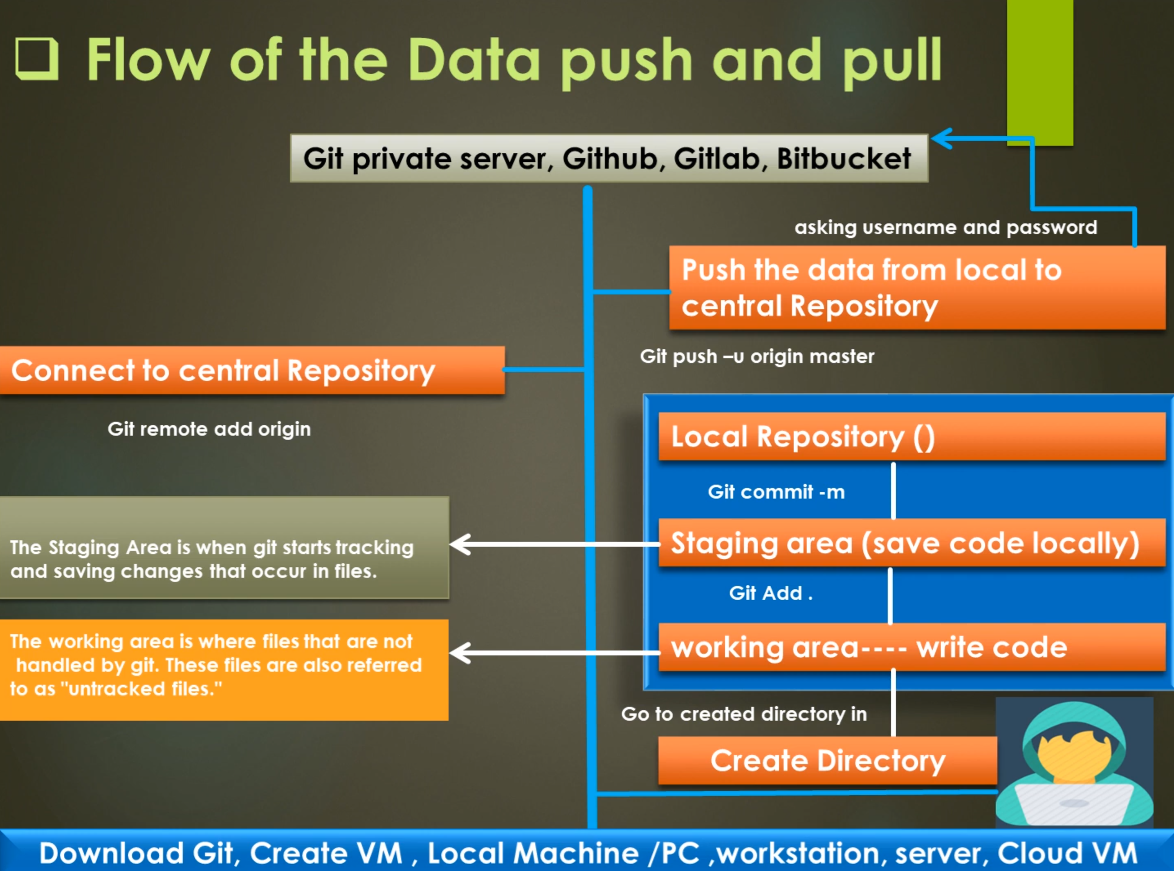

Configure global username and email

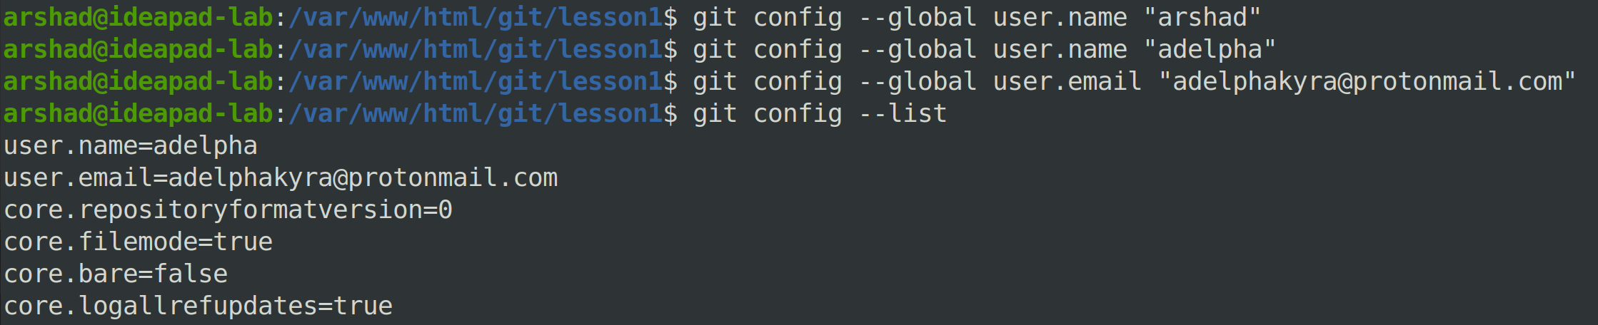

arshad@ideapad-lab:/var/www/html/git/lesson1$
git config --global user.name "arshad"

arshad@ideapad-lab:/var/www/html/git/lesson1$
git config --global user.name "adelpha"

arshad@ideapad-lab:/var/www/html/git/lesson1$
git config --global user.email "adelphakyra@protonmail.com"

arshad@ideapad-lab:/var/www/html/git/lesson1$
git config --list
user.name=adelpha
user.email=adelphakyra@protonmail.com
core.repositoryformatversion=0
core.filemode=true
core.bare=false
core.logallrefupdates=true

- When the above email and username are used, no connection is made with Protonmail server or any Git Repository. They are stored on the local Git server only.

arshad@ideapad-lab:/var/www/html/git/lesson1$ pwd
/var/www/html/git/lesson1

Configure global username and email

arshad@ideapad-lab:/var/www/html/git/lesson1$
git init
Initialized empty Git repository in /var/www/html
/git/lesson1/.git/

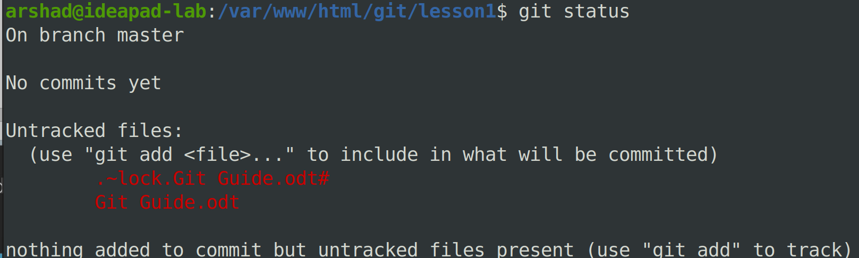
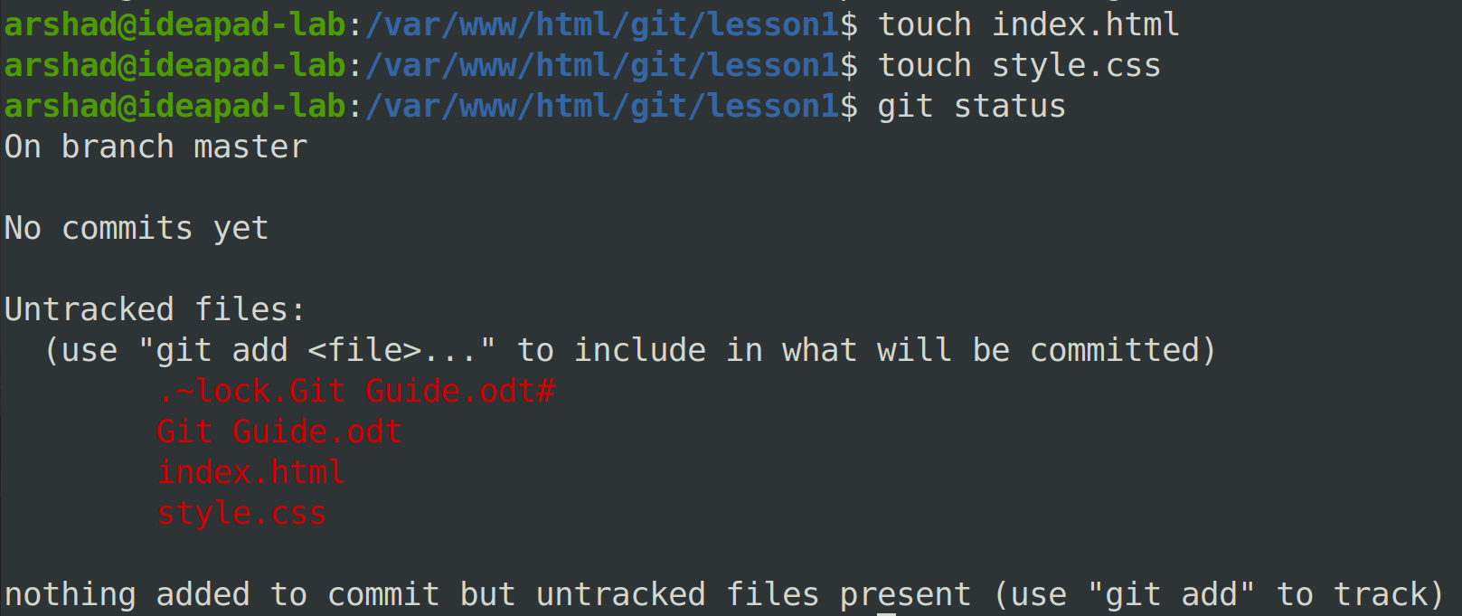

Write HTML codes via terminal
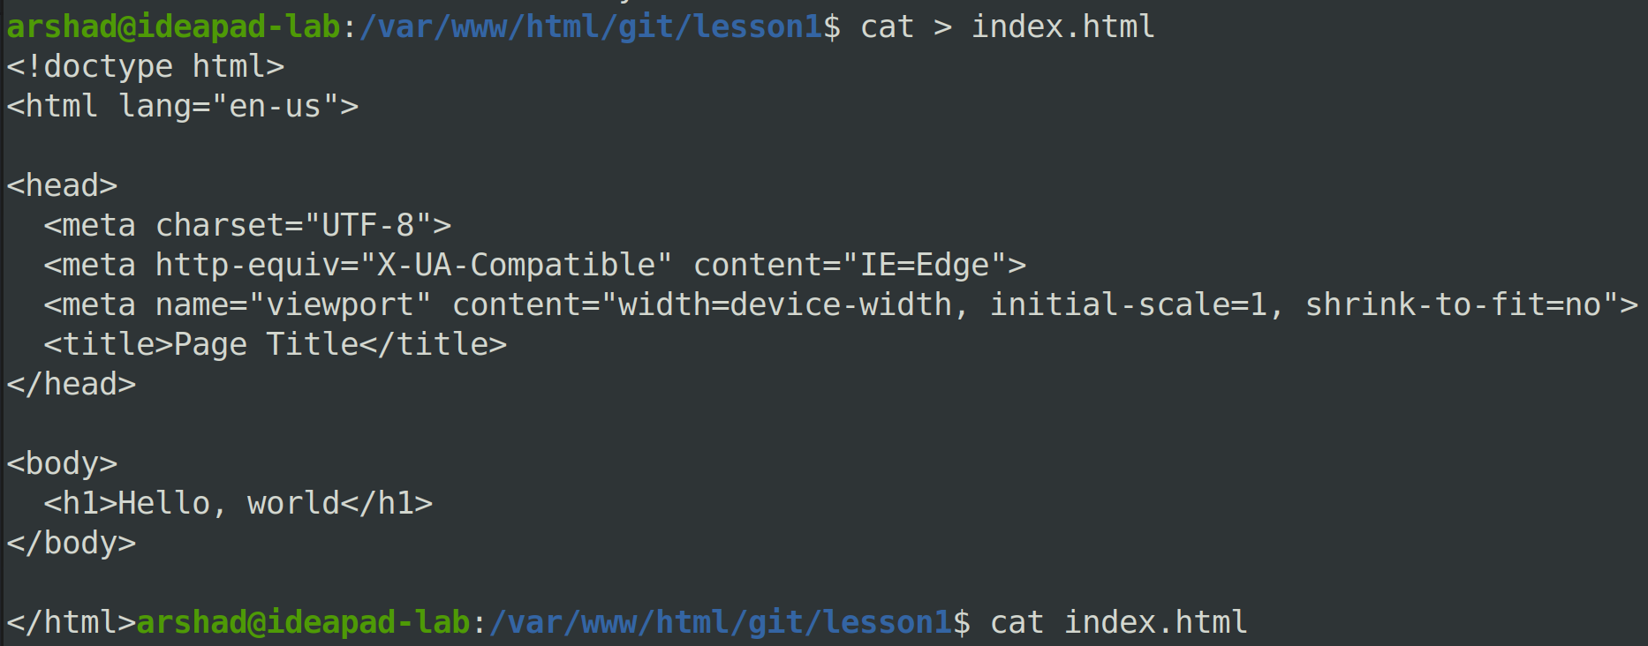

Moving files from Untracked to Stage Area
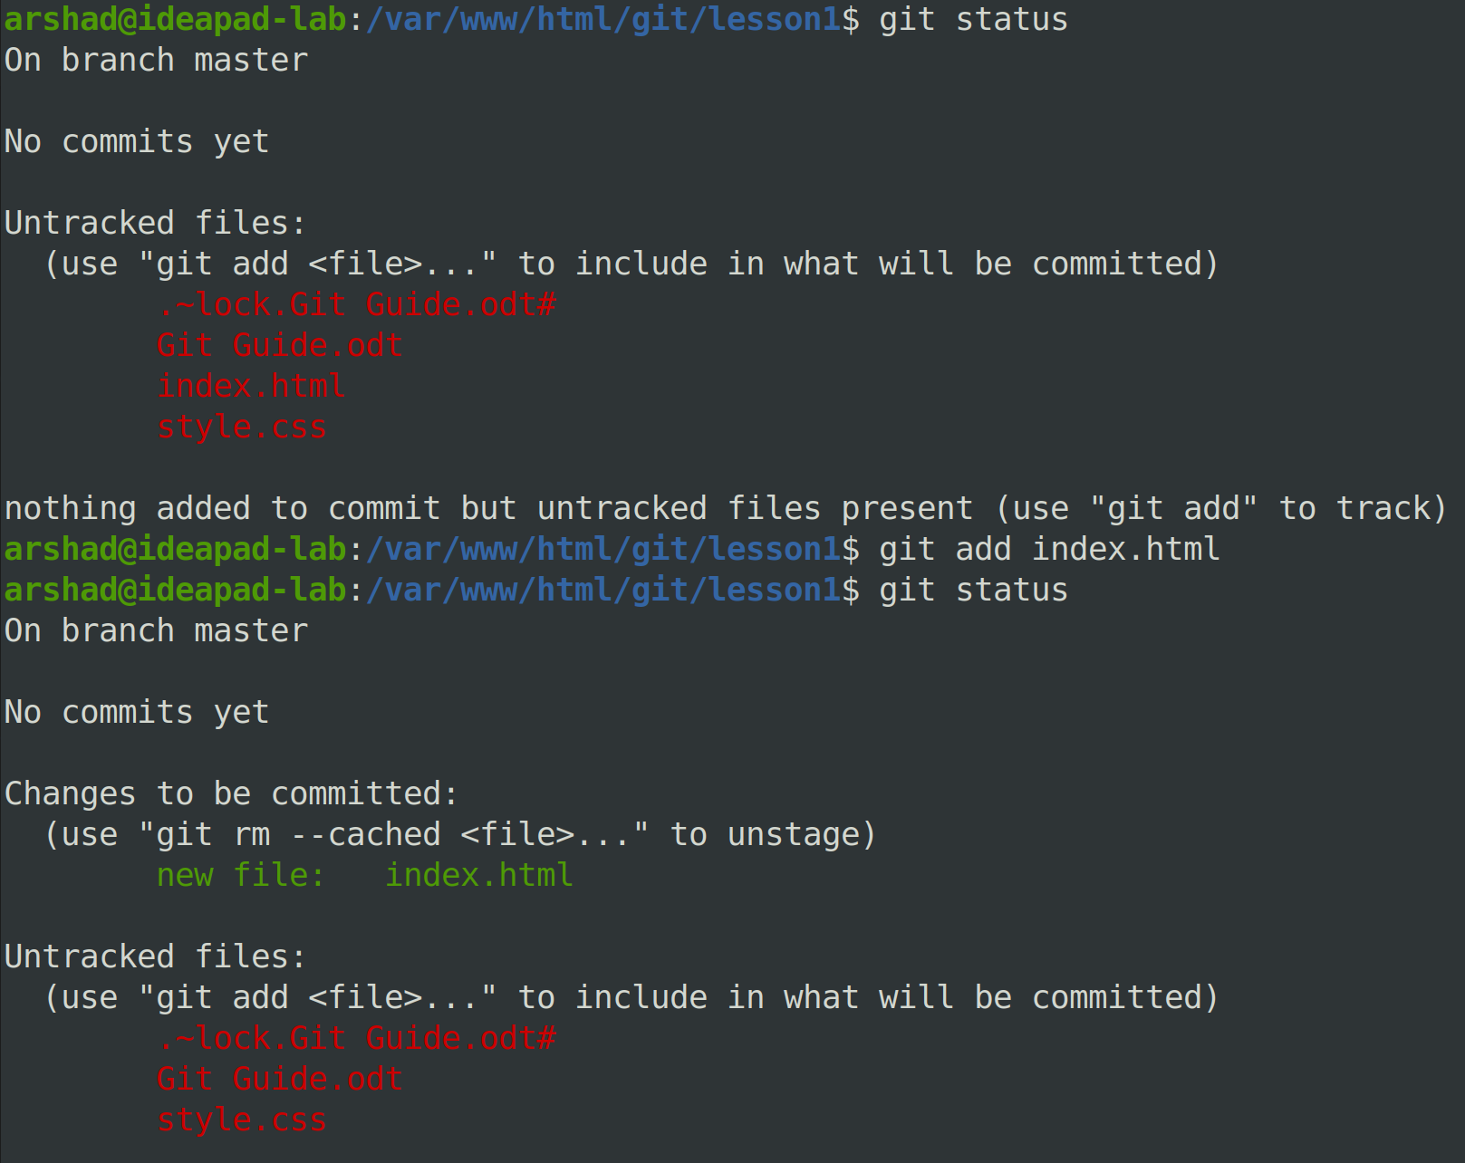

Display HTML via terminal

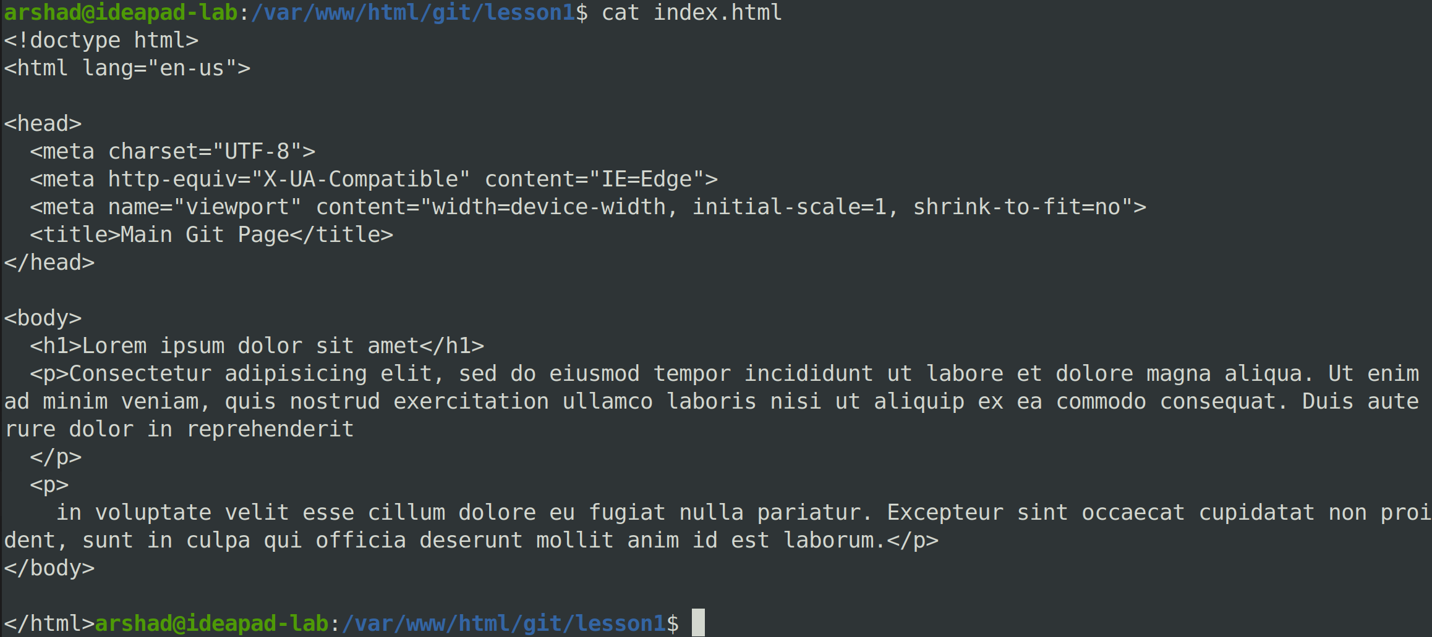

Commit file

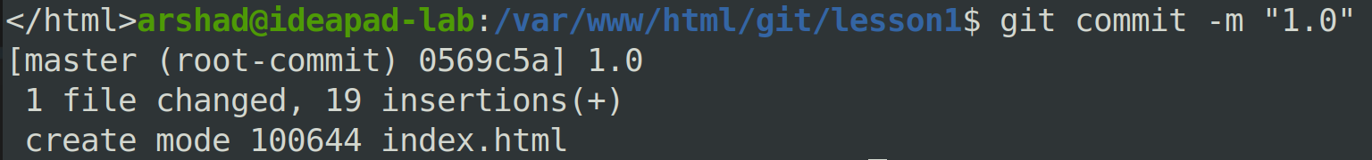

- Any message can be added in the double quotes “ ”.

Check commit files
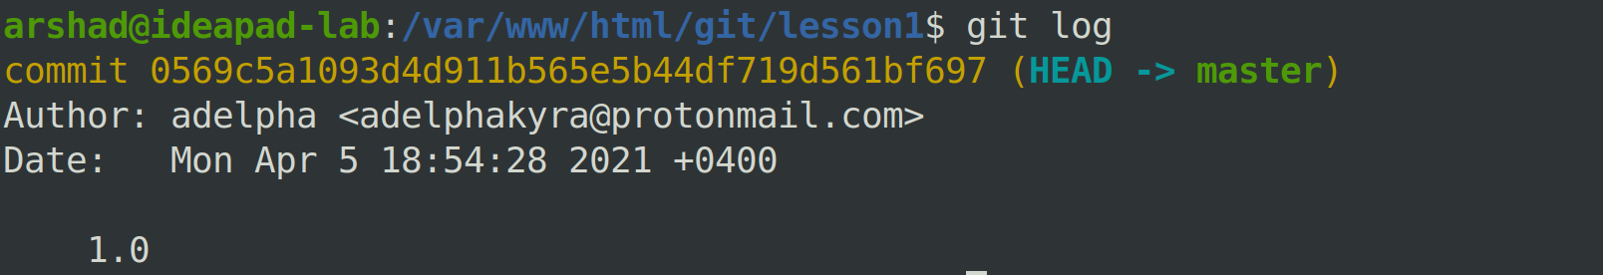

Open committed files

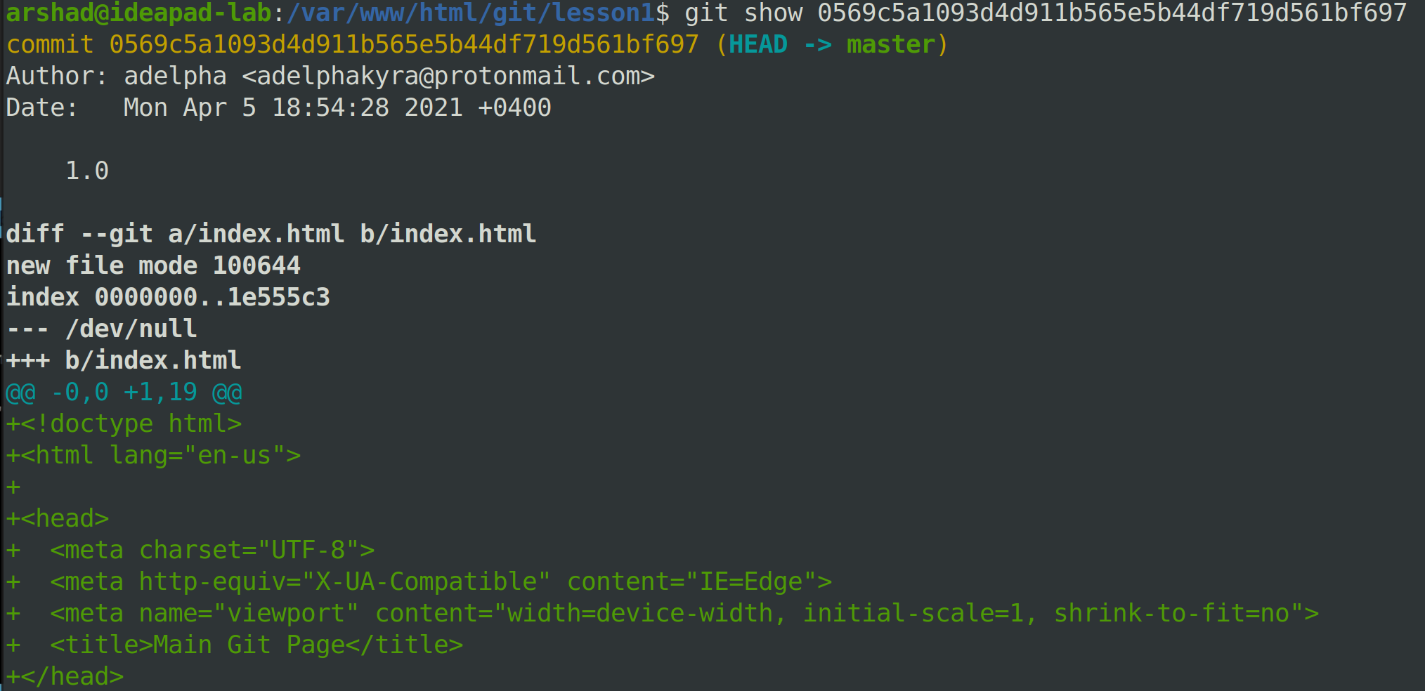

- Once a file is added, it will no longer appear among the tracked files. To list the existing files, [ls] should be used.
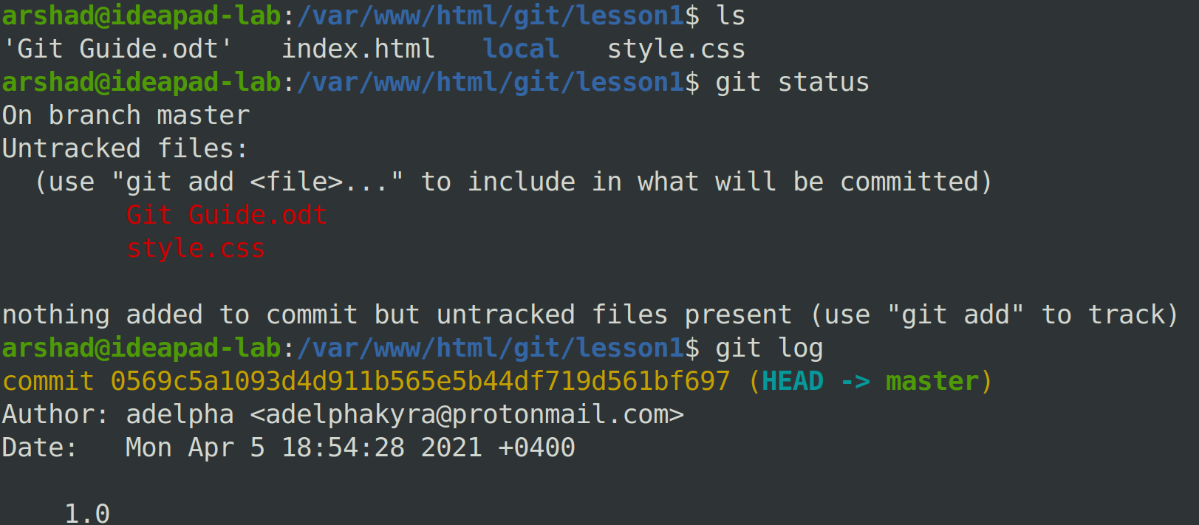

- If the whole content of a file is not displayed at once using

“git show 0569c5a1093d4d911b565e5b44df719d561bf697”,

press ‘Enter’ till all the lines are displayed.

